Trying to add an image within a text pane

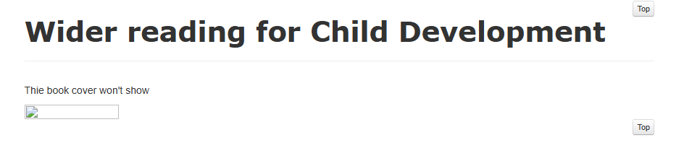

Trying to add an image pane or a carousel

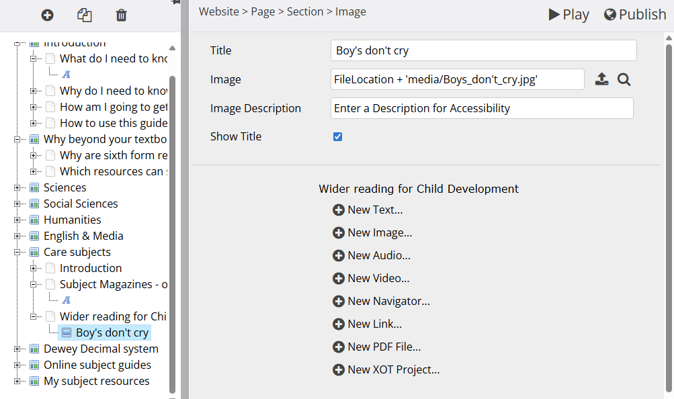

Whilst the small menu on the left still shows my Wider reading for Child Development section, it won’t show the content at all
