asfunction and pressed publish
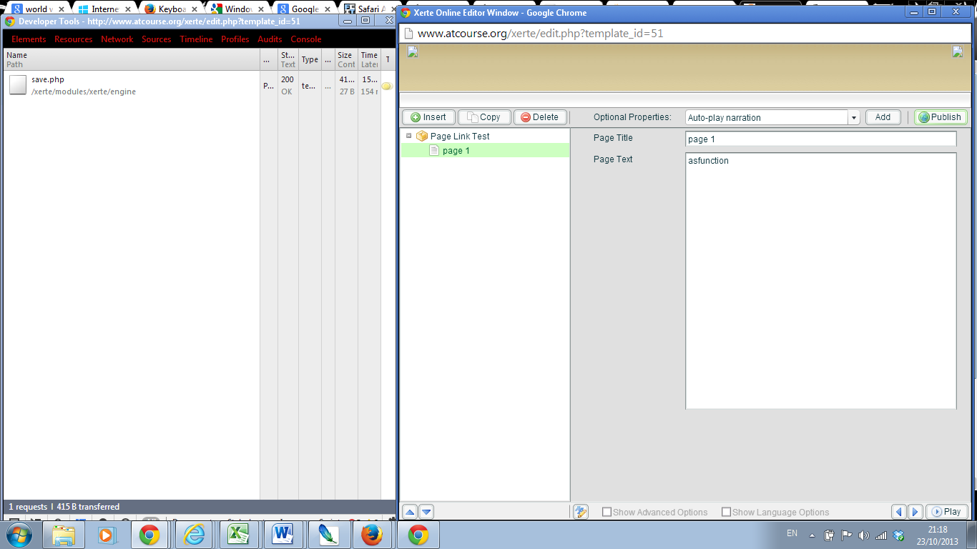
- filedata:
<learningObject language="en-GB" name="Page Link Test" navigation="Linear" textSize="12" displayMode="default"> <text linkID="PG1382559408071" name="page 1"><![CDATA[asfunction]]></text> </learningObject>
asfunction: and pressed Publish
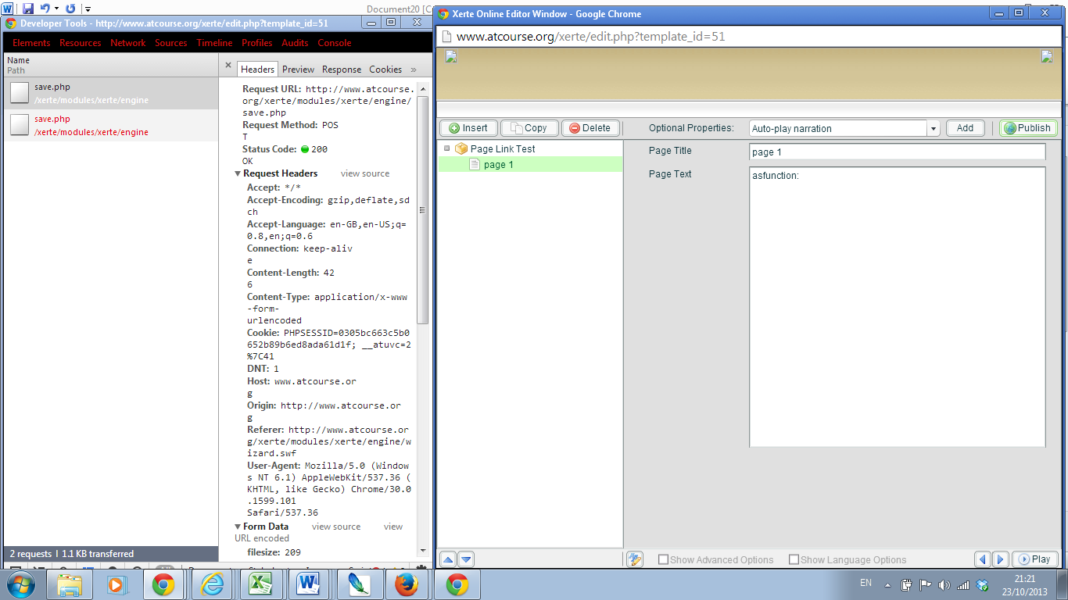
  - filedata:
<learningObject language="en-GB" name="Page Link Test" navigation="Linear" textSize="12" displayMode="default"> <text linkID="PG1382559408071" name="page 1"><![CDATA[asfunction:]]></text> </learningObject>
Added additional text (test test test) after asfunction: and tried to save again
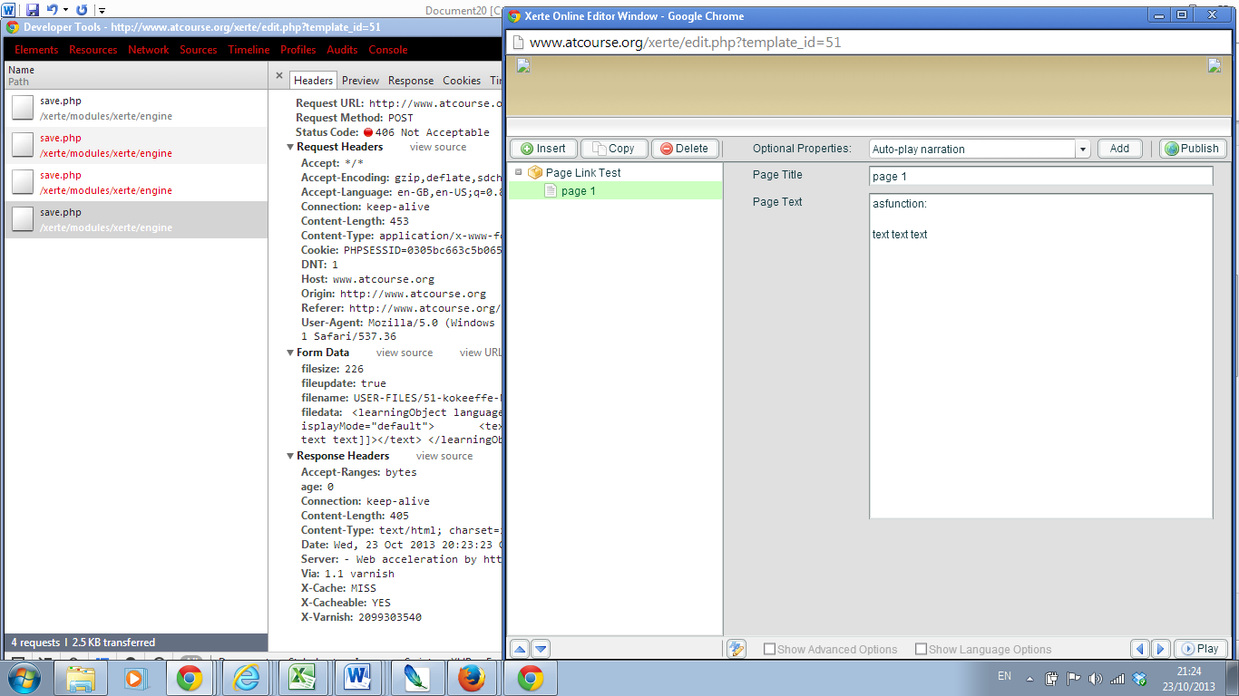
- filedata:
<learningObject language="en-GB" name="Page Link Test" navigation="Linear" textSize="12" displayMode="default"> <text linkID="PG1382559408071" name="page 1"><![CDATA[asfunction: text text text]]></text> </learningObject>
Closed and reopened editor window
