Padlet in Xerte
The good news is that, using NVDA screen reader, I was able to add contributions to the Padlet as well as read other contributions that were there already (for example the contribution I had already made).
The not so good news is that it was clunky and involved switching between Browse mode and Focus mode using the Insert + Spacebar command. In Focus mode I only got very ambiguous options as I tabbed through like “Add post to this section” without knowing what the section was or “Add comment” without seeing what the comment was – figure 1. However, in Browse mode (Ins + Spacebar) I could read the individual elements and interact accordingly.
The bad news is that for a sighted keyboard user it was impossible to see where the current tab focus was on Padlet. Xerte was easy to follow but Padlet’s tab focus was invisible, even using a plugin like focus indicator.
When I loaded the Padlet OUTSIDE of the Xerte page the focus was still impossible to see BUT the Focus Indicator plugin made it visible to me.
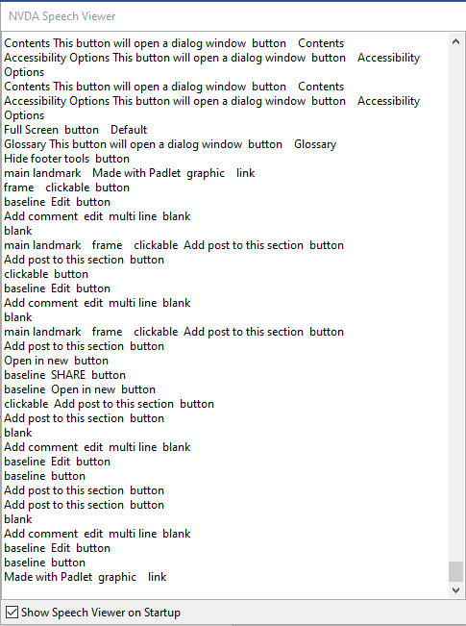
Figure 1
However, in the read mode I was able to get much more information as you can see in figures 2 & 3. I could read the colum headings as well as the comments I had added and I could add to the comments also – however Publishing was counterintuitive (see below).
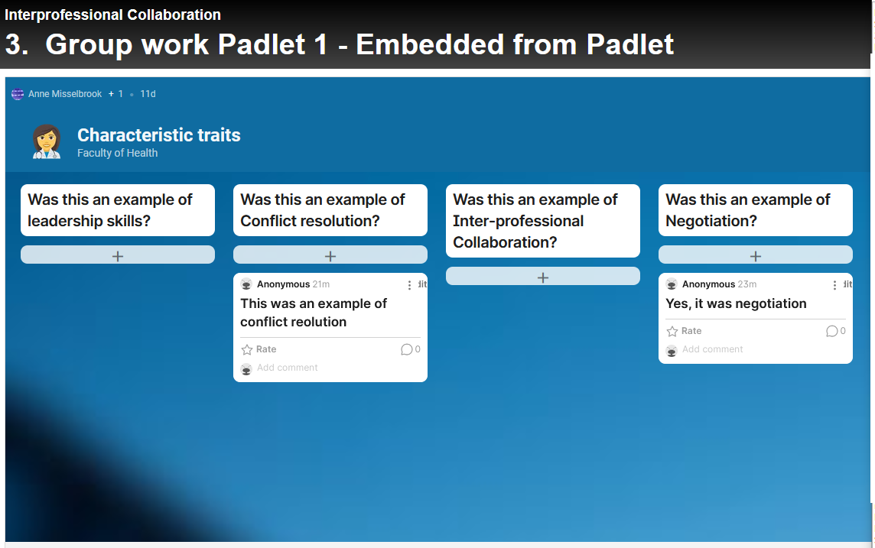
Figure 2
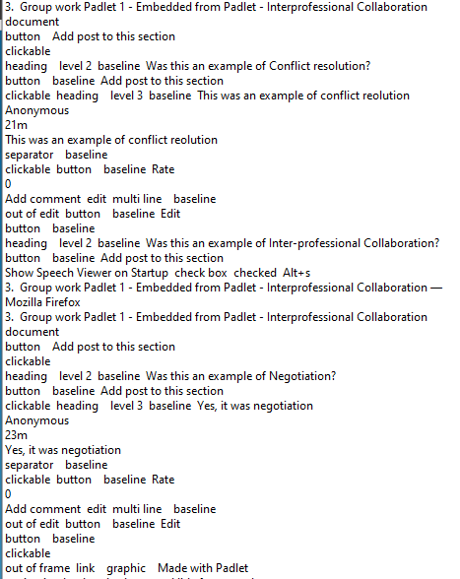
Figure 3

I was also able to add content to the public using NVDA but it took a long time to work out how to publish it because publish appeared to require me to shift tab once I had entered the content I wanted. If I continue tabbing I seem to go through lots of other options and eventually leave the dialogue box without publishing. This is very much a Padlet behaviour, not a Xerte toolkits behaviour.
Finally, I found the pop-up section options where you add a comment very confusing to navigate with a screen reader. I don’t know if it’s possible to switch these off? Also I had no idea what the White button signified – neither as a sighted user nor screenreader amateur. it’s possibly feature bloat in Padlet?

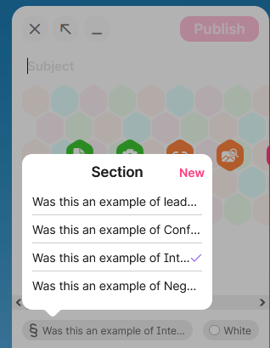
Figure 4

In conclusion, I’d say that the embedded Padlet was screenreader accessible in the sense of being possible to complete, however you might want to give some guidance, particularly about how to publish. My big worry was that pamphlet does not seem to be accessible to sighted keyboard users due to the lack of tab visibility. In a case like this I would normally just advise people to use the Focus Indicator plug-in for Chrome but it’s currently giving a 404 error on the Chrome Web store so I’m not sure still available.
I tested with NVDA on Firefox. I tested the tab visibility on both Firefox and Chrome.

Alistair McNaught Aug 2021

