Titlepage in verder leeg object:

broncode en printscreens in nieuwe editor:
<p><strong>​JPG</strong></p>

<p><img alt="" src="http://privatebeta.xerte.org.uk/USER-FILES/62-Loe-Nottingham/media/test1.JPG" /></p>

<p><strong>jpg</strong></p>

<p><img alt="" src="http://privatebeta.xerte.org.uk/USER-FILES/62-Loe-Nottingham/media/test2.jpg" /></p>

<p><strong>PNG</strong></p>

<p><img alt="" src="http://privatebeta.xerte.org.uk/USER-FILES/62-Loe-Nottingham/media/test3.PNG" /></p>

<p><strong>png</strong></p>

<p><img alt="" src="http://privatebeta.xerte.org.uk/USER-FILES/62-Loe-Nottingham/media/test4.png" /></p>

<p>==================================================</p>

<p><img alt="" height="29" src="http://privatebeta.xerte.org.uk/USER-FILES/62-Loe-Nottingham/media/test1.JPG" width="129" /></p>

<p><img alt="" height="32" src="http://privatebeta.xerte.org.uk/USER-FILES/62-Loe-Nottingham/media/test2.jpg" width="131" /></p>

<p><img alt="" height="30" src="http://privatebeta.xerte.org.uk/USER-FILES/62-Loe-Nottingham/media/test3.PNG" width="132" /></p>

<p><img alt="" height="28" src="http://privatebeta.xerte.org.uk/USER-FILES/62-Loe-Nottingham/media/test4.png" width="130" /></p>

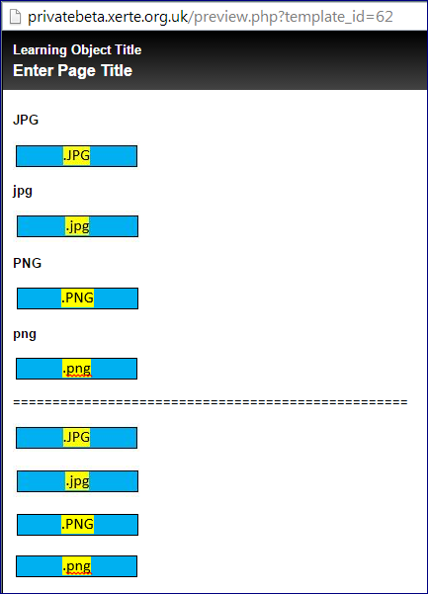

Export gemaakt naar Pantarijnomgeving
Weer de broncode. Een printscreen kamen heeft geen zin, want de afbeeldingen die wel in media staan worden niet gevonden.

<p><strong>​JPG</strong></p>

<p><img src="FileLocation + 'media/test1.JPG'" /></p>

<p><strong>jpg</strong></p>

<p><img src="FileLocation + 'media/test2.jpg'" /></p>

<p><strong>PNG</strong></p>

<p><img src="FileLocation + 'media/test3.PNG'" /></p>

<p><strong>png</strong></p>

<p><img src="FileLocation + 'media/test4.png'" /></p>

<p>==================================================</p>

<p><img alt="" height="29" src="FileLocation + 'media/test1.JPG'" width="129" /></p>

<p><img alt="" height="32" src="FileLocation + 'media/test2.jpg'" width="131" /></p>

<p><img alt="" height="30" src="FileLocation + 'media/test3.PNG'" width="132" /></p>

<p><img alt="" height="28" src="FileLocation + 'media/test4.png'" width="130" /></p>

